Wake Up Bus
ESRS – “Wake-Up Bus” Project
“Wake up Europe – don´t sleep at the wheel!”

Second update information

Activities of the project:

1. European awareness campaign about sleepiness at the wheel. A Wake-up bus will run through Europe starting in Portugal and ending in Brussels. An awareness campaign will be run by the National Sleep Society of each country visited by the Wake up bus.
2. European sleep study on “Sleepiness and Accidents”
3. Creation of an ESRS expert panel on “Sleep and Driving” which performs a state of the art review and an proposal for an action plan to be delivered to EU officials
4. A one-day symposium at the EU Parliament in Brussels as the final “highlight” of the campaign

Current status of participation in the different activities
The following countries have declared their interest to participate in the project:
 | BUS | AWARENESS CAMPAIGN | SLEEP STUDY
AUSTRIA | Yes | Yes | Yes
BELGIUM |  |  | Yes
CROATIA | Yes | Yes | Yes
ESTONIA | Yes | Yes
FINLAND | Yes | Yes
FRANCE | Yes | Yes | Yes
GERMANY | Yes | Yes | Yes
GREECE |  |  | Yes
ICELAND |  | Yes | Yes
ITALY | Yes | Yes | Yes
LITHUANIA |  | Yes | Yes
POLAND | Yes | Yes | Yes
PORTUGAL | Yes | Yes | Yes
ROMANIA | Yes | Yes | Yes
SERBIA | Yes | Yes | Yes
SLOVENIA | Yes | Yes | Yes
SPAIN | Yes |  | Yes
SWEDEN | Yes | Yes | Yes
THE NETHERLANDS |  |  | Yes
TURKEY |  |  | Yes

Awareness campaign about sleepiness at the wheel

Bus tour

The awareness bus will take the following route:

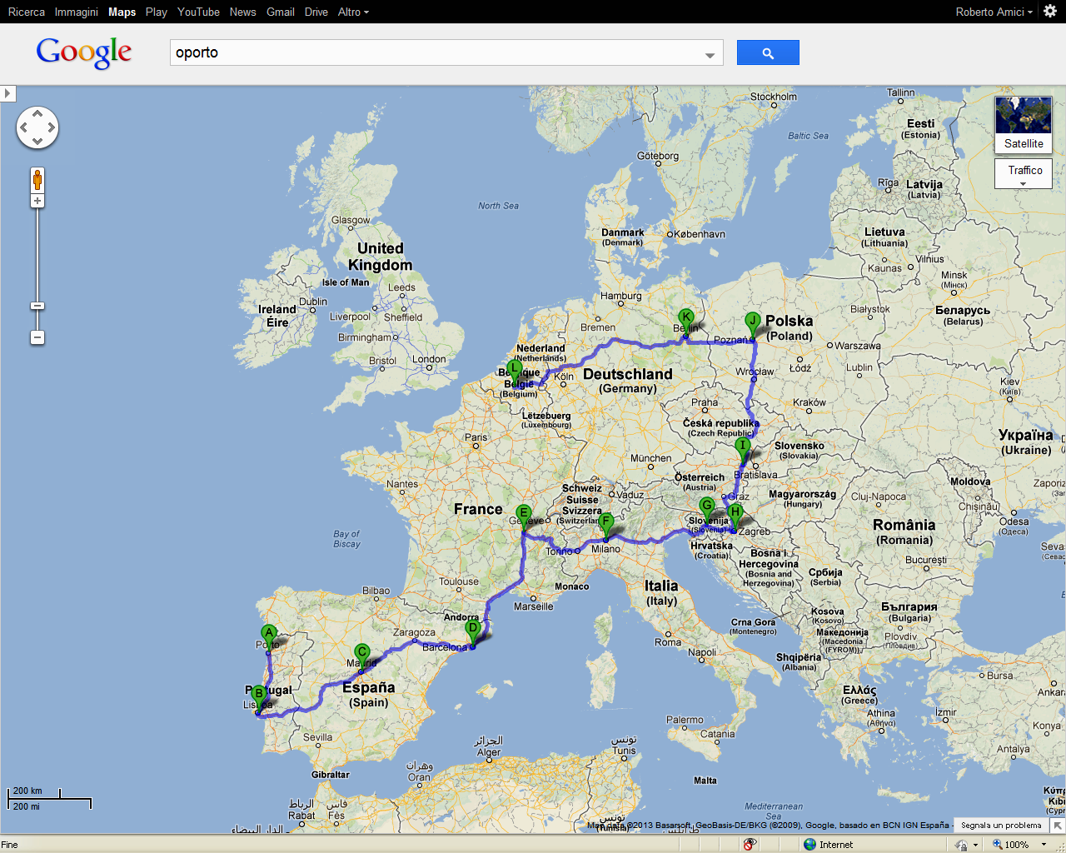

The timetable (see below) has been constructed. For every country, the date (morning or afternoon) in which the main public event will be held is shown in bold. When the bus arrives at the designated meeting point, the Society president and representatives will join the bus group. Educational material such as brochures, videos and others (translated into the different languages) will be distributed from the bus. Concomitantly, an awareness campaign involving media will be launched at National level. The final deadline is the Brussels meeting on October 15th.
 | Morning | Afternoon | Night
Oct 3 THU | OPORTO trip to Lisbon (3h) | LISBON | LISBON
Oct 4 FRI | trip to Madrid (6h) |  | MADRID
Oct 5 SAT | MADRID | trip to Barcelona (6h) | BARCELONA
Oct 6 SUN | trip to Lyon (6h) |  | LYON
Oct 7 MON | LYON | trip to Milan (5h) | MILAN
Oct 8 TUE | MILAN | trip to Ljubljana (5h) | LUBIJANA
Oct 9 WED | LJUBIJANA | trip to Zagreb (3h) | ZAGREB
Oct 10 THU | ZAGREB | trip to Wien (4h) | WIEN
Oct 11FR | WIEN | trip to Wroclaw or Katowice (6h) | WROCLAW (or KATOWICE)
Oct 12 SAT | POZNAN | trip to Berlin (4h) | BERLIN
Oct 13 SUN | BERLIN | trip to Brussels (7h) | BRUSSELS
Oct 14 MON |  |  | BRUSSELS
Oct 15 TUE |  | MEETING with the EU | BRUSSELS

The bus stop in Zagreb may represent the opportunity for several Eastern countries to start their regional activities. We expected a join action In Zagreb with a big party there. In Berlin representatives from the Nordic Countries will hopefully join the Bus.
PR Company: Information material

The travel of the bus has to be accompanied by a structured PR activity both on the central level (Portuguese part) and in each country where the bus will stop. Marta G and the organization GCI, which is the Portuguese branch of the international company Edelman PR, have generated a media campaign including a video, information material and advertisement for the sleep study.

The education material, after being reviewed and approved by the expert panel, has been produced in Portuguese and English on a digital support. The artwork of this material will be send to all National Sleep Society for translation in the National language, introduction of the logos of their society and their sponsors, due to each NSS print as many copies as required
The blue prints of the material will be sent soon (at the end of August) to the presidents of the NSS, so the NSS´s will have enough time to print their own material to be used in their campaign.
The video and radio clips will be generated in English. In case the NSS want to run them on TV, they will need a special cassette; the costs need to be paid to the advertising company.

European sleep study on “Sleepiness and Accidents”
The sleep study has been designed by the expert panel and the technical solution has been implemented by Jennifer Thomsen from Congrex and Brigitte Knobl from the ESRS (PLEASE activate http://www.esrs.eu/sleepstudy.html). 18 countries are now participating which is a huge success!!
The start of the sleep study will be in the middle of July, digital advertisement material have been created and prepared for adaptation to any language for an online advertisement (see in attachment) considered the better way of advertise a online study. Now it is up to all National Sleep Societies to adapt this and prepare a press release to announce the start of the study in social and digital media as well in newspapers.
Data collection is open until the the end of August which gives all NSS a proper time window to run the campaign for the sleep study (> 6 weeks from now).
All data will be collected by ESRS and analyzed by the Project´s coordinators. The results of each country will be sent to each NSS and to the expert panel. The study results should be embargoed until the day the bus arrives at each Country (to attract journalists) along the way to Brussels
All NSS participating in the sleep study will be asked to contribute with 500 Euros to the ESRS to cover at least part of the costs related to the management of the sleep study.

ESRS expert panel on “Sleep and Driving”
The ESRS board has appointed a specific expert panel and the EU Bus organizers would like to express their gratitude for their work in the project..
- Torbjorn Akerstedt (Sweden)
- Fabio Cirignotta (Italy)
- Jim Horne (UK)
- Damien Leger (France)
- Walter McNicholas (Ireland)
- Markku Partinen (Finland)
- Joaquin Teran-Santos (Spain)

One-day symposium at the EU Parliament in Brussels

The day will be Thursday the 15th of October. The preparations are ongoing. The final program is discussed within the project group. The days around the meeting can be used to expose the ESRS and the topic “Sleep” in the EU parliament. The Belgian Sleep Society will be active to make this an excellent opportunity for information transfer of sleep to European parliamentarians. The information material of the EU Bus Campaign will be used (video etc.).
It is of high importance that all Presidents of the NSS involved in the ANSS will participate in the EU meeting in Brussels. In addition, interest groups, representatives from companies, all sponsors and patient interest groups are warmly welcome to join the event. A specific invitation will be sent out to all separately. Please mark this day already in your calendar!!

Overview: Milestones of the project

- List of participating countries (reached)
- Sleep study: Protocol, questionnaire are written/approved – reached
- Bus, drivers, and route of the travel are fixed - reached
- PR company in Portugal approved and information material is printed – almost reached
- Expert panel is formed and has approved study and information materials - reached
- Sponsors for central parts of the project are contracted –ongoing activity
- Meeting of the ANSS in Copenhagen, May 3rd with information and discussion about the national campaigns related to the Bus Travel – reached
- Performance and evaluation of the study (summer 2013) – start July 2012
- Brussels meeting: Preparations together with PR company and the NSS – ongoing

- Sleep study: National media activity to announce participation in the survey – important activity during summer 2013
- National sleep society active in the National Bus Campaign – most crucial now is to organize the national campaign (content, type of activities, media activity, sponsors etc.) –main work to be performed in the NSS

We are grateful for any comments and your support. We wish you all a restful summer time.

Best regards from your project group

Marta Goncalves, Project Coordinator, Member Executive Committee ANSS and EU Committee, ESRS
Ludger Grote, Chair Executive Committee Assembly of National Sleep Societies, ESRS
Roberto Amici, Chair EU Committee, ESRS
Philippe Peigneux, President of the ESRS

